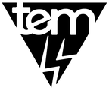
The Electric Movement
(Insert Caption)
(Insert Sub-Caption)

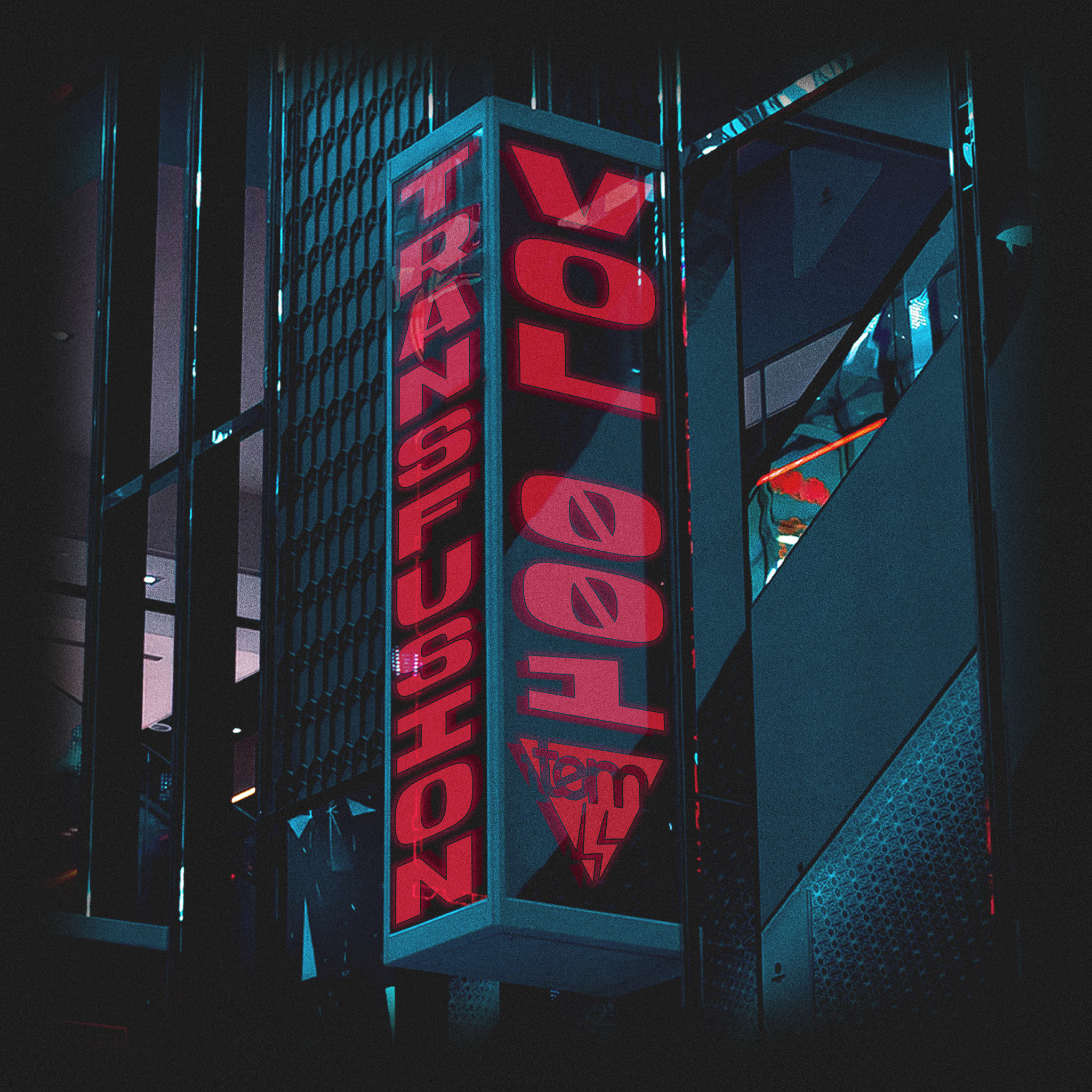

- Pre-Save
- Private Streaming
- Artwork
- Video (Insert / link Assets)

Copyright © 2022 The Electric Movement, All Rights Reserved. (Subject To Change)
(Song / Album Title - Artist(s):
(Insert Date)

New Orleans, LA - In March of 2020, a collective was formed with a goal to unify lovers of art, music, and culture into a hivemind known as The Electric Movement. T.E.M. are tastemakers within the dance-music sector that are pushing the envelope for artists and fans alike. Now, they present their first, multi-artist, music compilation, “Transfusion.” (Biography)

Providing a gateway for artists and fans, T.E.M. has captivated people with their events and online music festivals. One might have even listened to their mix series, “Monday Movement,” which is growing across the Electronic / Bass landscape like wildfire on SoundCloud. (Additional Bio)

“All we wanted was to give everyone something like a sanctuary where they could go to experience dance music culture during the pandemic. We grew fast and began to connect with each other like a beehive. “ (Cliffhanger / Close Bio)
- Daniel with T.E.M.

The compilation album is a Bass-infused selection of up-and-coming acts, including: Don Peyote, WeeWah, Solfire x Dooley, Thred, Raid Value, M8TRX, Subhunter, KRAMEX, MANDA, and Noetika. Transfusion will be available for streaming beginning September 20th, 2022. With a flourishing content schedule and a passion for the culture, it’s a no brainer to join The Electric Movement as they pave the way for up-and-comers to showcase their talent(s). (Release Information / Description)

Copyright © 2022 The Electric Movement, All Rights Reserved.

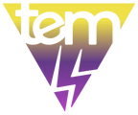

Follow The Electric Movement:
Website
SoundCloud
Twitter
Instagram
Twitch
Discord
YouTube
Facebook

(Insert Plugs / Socials)

For all Press Inquiries:
temcoofficial@gmail.com

Copyright © 2022 The Electric Movement, All Rights Reserved.

